**Task 2: Data Visualization and Storytelling**

**Introduction: Dataset Overview**

* Sales Store Dataset with 9,994 orders across 4 years (2014–2018)
* 🇺🇸 Sales from across the United States
* 21 columns covering Orders, Customers, Products, Discounts, Profits, etc.
* Objective: Uncover sales patterns, customer behaviour, and key opportunities.

**Tools:** Tableau

**VISUALIZATIONS:**

| **Visualization** | **Insight** |
| --- | --- |
| **1. Sales Over Time (Line Chart)** | Peak sales observed during **Q4 of each year** – seasonal boost likely from holiday sales. |
| **2. Sales & Profit by Category (Bar Chart)** | **Office Supplies** has high sales but **low profit margin**, while **Technology** yields more profit. |
| **3. Region vs Segment (Stacked Bar)** | **West** leads in sales; **Consumer** segment dominates across all regions. |
| **4. Top Cities (Horizontal Bar)** | **New York City**, **Los Angeles**, and **Seattle** are top-performing cities in revenue. |
| **5. Profit vs Discount (Scatter Plot)** | High discounts often lead to **negative profits** – over-discounting may hurt revenue. |
| **6. Pie Chart: Sales by Region** | **West (32%)** and **East (28%)** are the strongest regions; South & Central lag behind. |

**DASHBOARDS:**

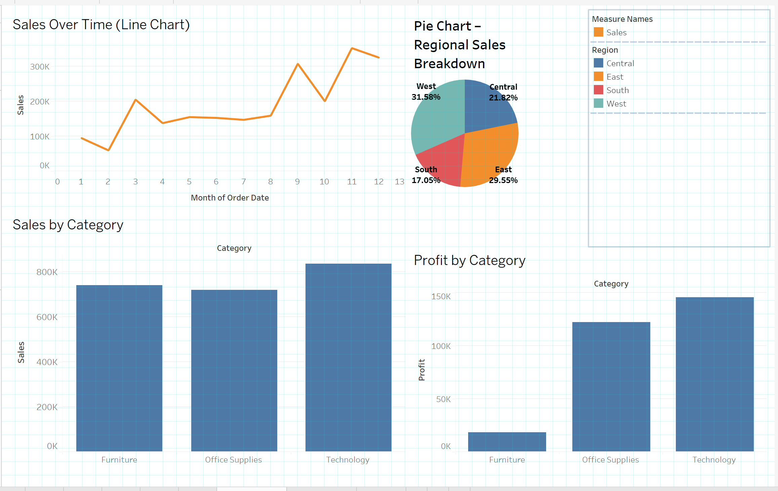

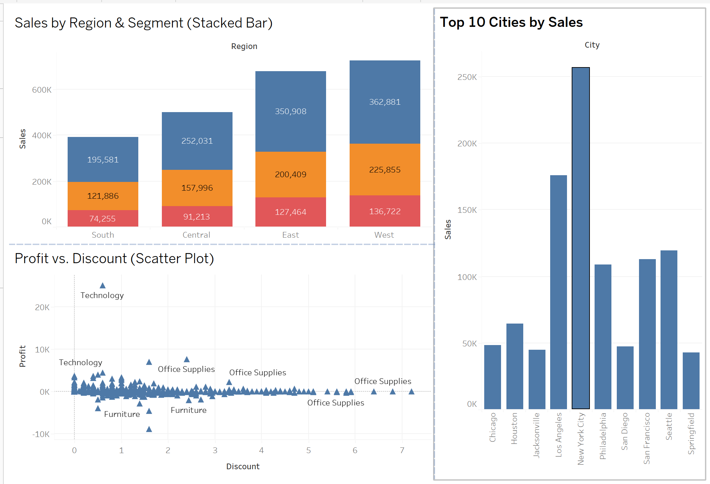

**STORYBOARD:**

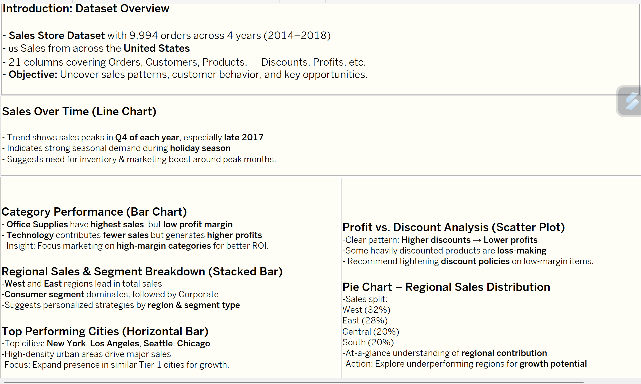

**Summary:**

* Focus on **high-profit categories** (like Technology) rather than just high sales.
* **Review discount strategies**—deep discounts reduce overall profitability.
* **Leverage strong markets** (West & East) and expand in **underperforming regions**.
* **Plan for Q4** sales spikes—optimize stock and delivery during holiday seasons.